STUDENT NAME:MAUREEN WAIRIMU
ADM NO:BSCCS/2025/68877
COURSE:COMPUTER SCIENCE
UNIT TITLE: ETHICAL HACKING
UNIT CODE: BIT 4139.
LECTURER NAME: MR MICHAEL NYORO
SELECTED TOOL:NMAP.

Contents
Fig1:Setting up environment variables 3
Fig2:Nmap installed 4
Fig 3:Ping scan Address 192.168.1.0/24 4
Fig4:Port scanning:192.168.1.50 5
Fig5:Footprinting 5
Student reflection: 5
STEPS IN ETHICAL HACKING 5
IDENTIFYING TARGET INSTITUTION 5
Domain information: 6
Subdomains: 6
Domain registrar 6
IP Address 7
Email patterns 7
Technologies running: 8
Leaked credentials: 8
Student reflection 8
Findings 9
Security Risks 9
Task 2 9
SCANNING AND ENUMARATION 9
Scanning ports: 9
OS version scan: 10
Student reflection 12
Week 6: Vulnerability Assessment and Scanning 12
Practical Task 1 12
Basic Vulnerability Scan 12
Practical Task 2 12
Vulnerability Research Assignment 12
Research five recent vulnerabilities. 12
Practical Task 3: Organizational Vulnerability Assessment Plan 14
Advanced Practical Task 14
Vulnerability tracking spreadsheet 14
Challenge Task 14
WEEK 7 15
Practical Task 1 15
OWASP Top 10 Research 15
1. Broken Access Control 15
2. Cryptographic Failures 15
3. Injection 16
4. Insecure Design 16
5. Security Misconfiguration 16
6. Vulnerable and Outdated Components 17
7. Identification and Authentication Failures 17
8. Software and Data Integrity Failures 17
9. Security Logging and Monitoring Failures 18
10. Server-Side Request Forgery (SSRF) 18
Practical Task 2 18
Web Application Assessment 18
Practical Task 3 18
Security Improvement Proposal 18
Advanced Practical Task 19
Challenge Task 20

WEEK ONE:
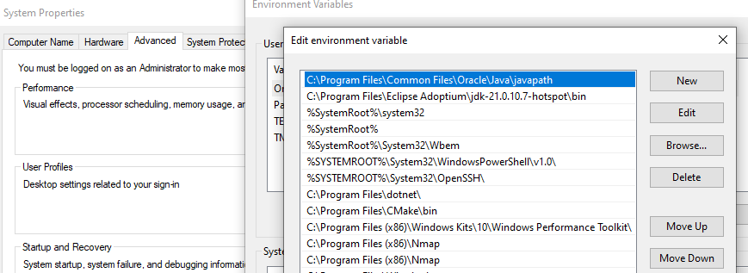
Fig1:Setting up environment variables.
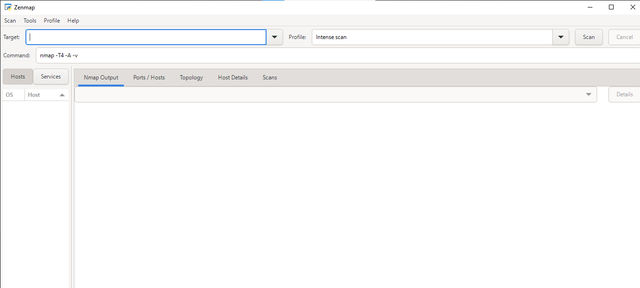
Fig2:Nmap installed.
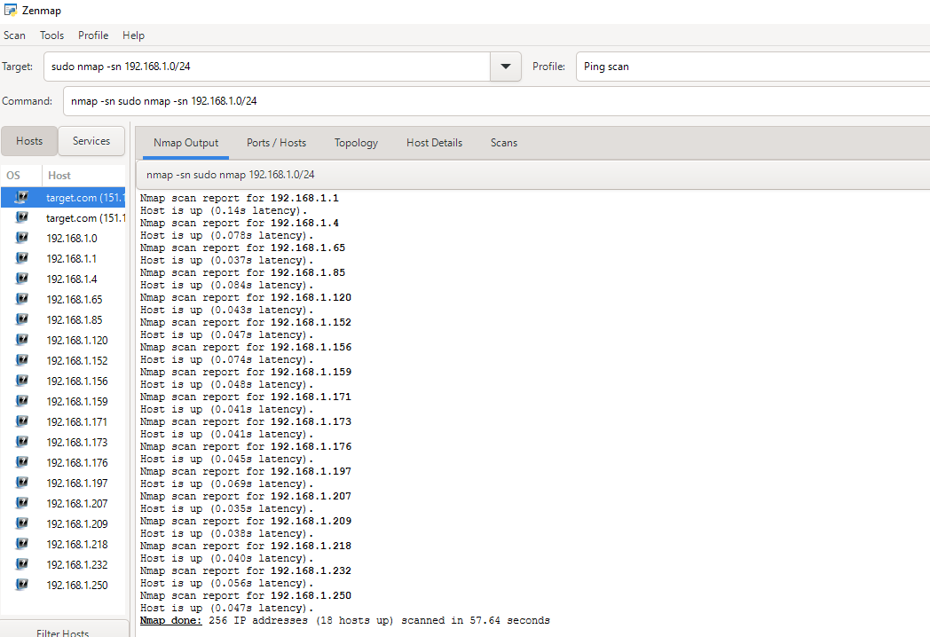

Fig 3:Ping scan Address 192.168.1.0/24
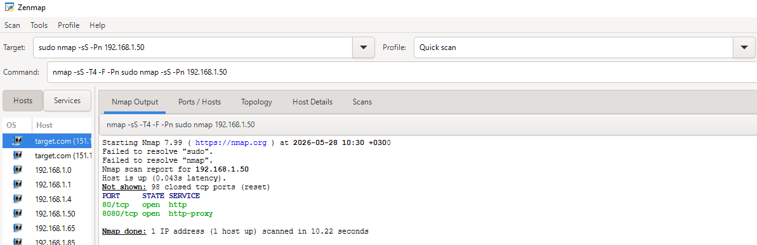

Fig4:Port scanning:192.168.1.50
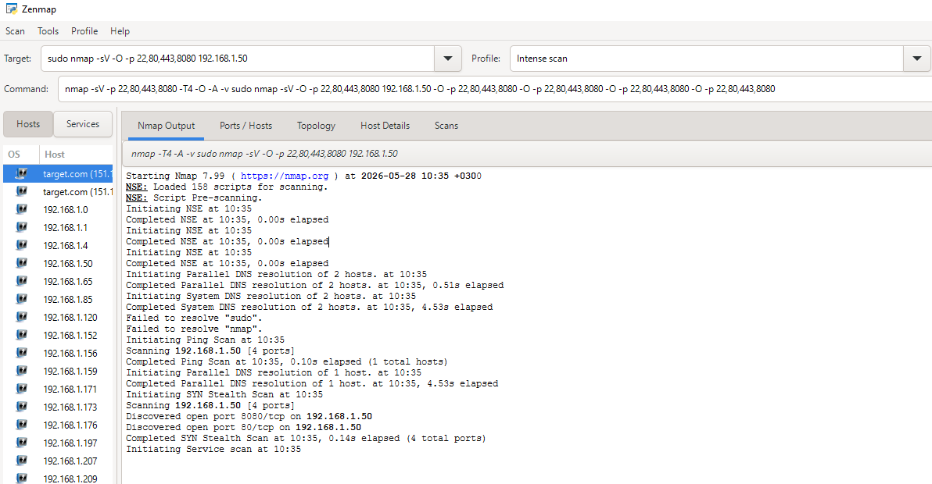

Fig5:Footprinting

Student reflection:
What I have learnt while in week one is how to set up a penetration tool,perform basic scans using ip address and determine the output given .
STEPS IN ETHICAL HACKING.
IDENTIFYING TARGET INSTITUTION.

Domain information:
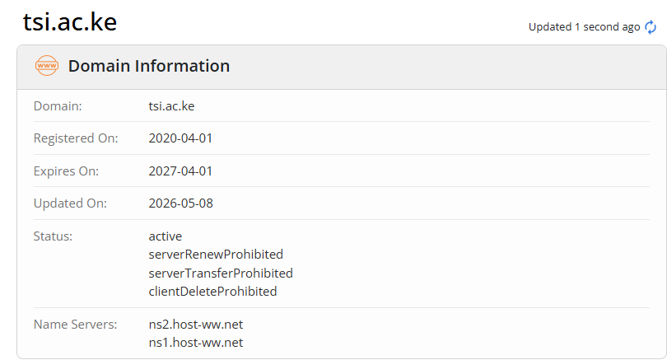

Subdomains:
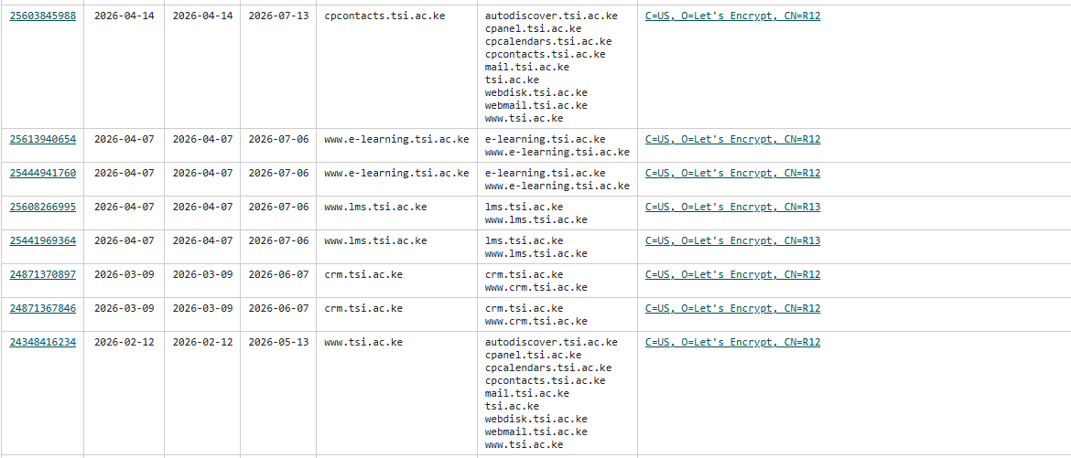
Domain registrar:
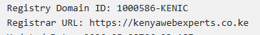

IP Address
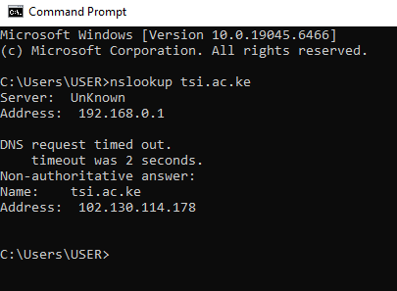

Email patterns


Technologies running:
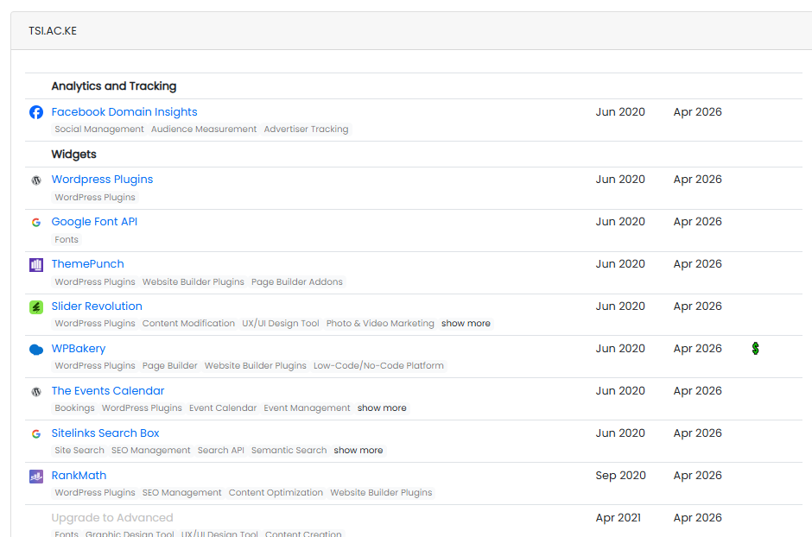

Leaked credentials:
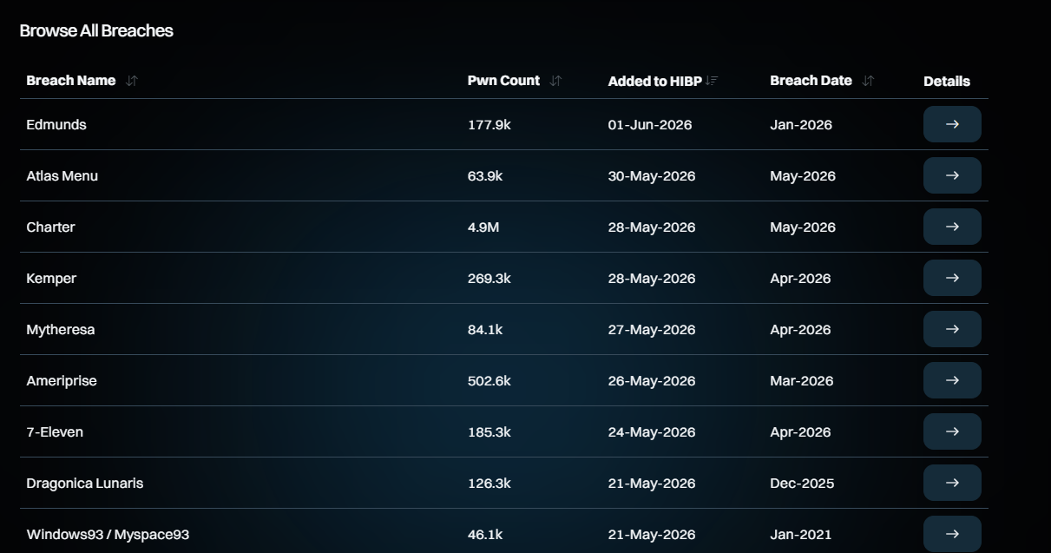
Student reflection:
What I have learnt while perfoming task one is how to gather information from publicly accessible tools such as WHOIS,OSNIT which provides details such as domain registrar ,ip address and others.This helps you understand the system better such as when it was registered,updated and when it expires.This helps one find opportunities for vulnerabilities recognize the patterns.All this basically help the hacker get their objectives in place.

Findings
- Domain and IP publicly accessible.
- Predictable email format
- Technologies identified through headers and nmap scans

Security Risks
- Predictable email format increases risk
- Subdomains may have weaker security controls.

Task 2

SCANNING AND ENUMARATION

Scanning ports:
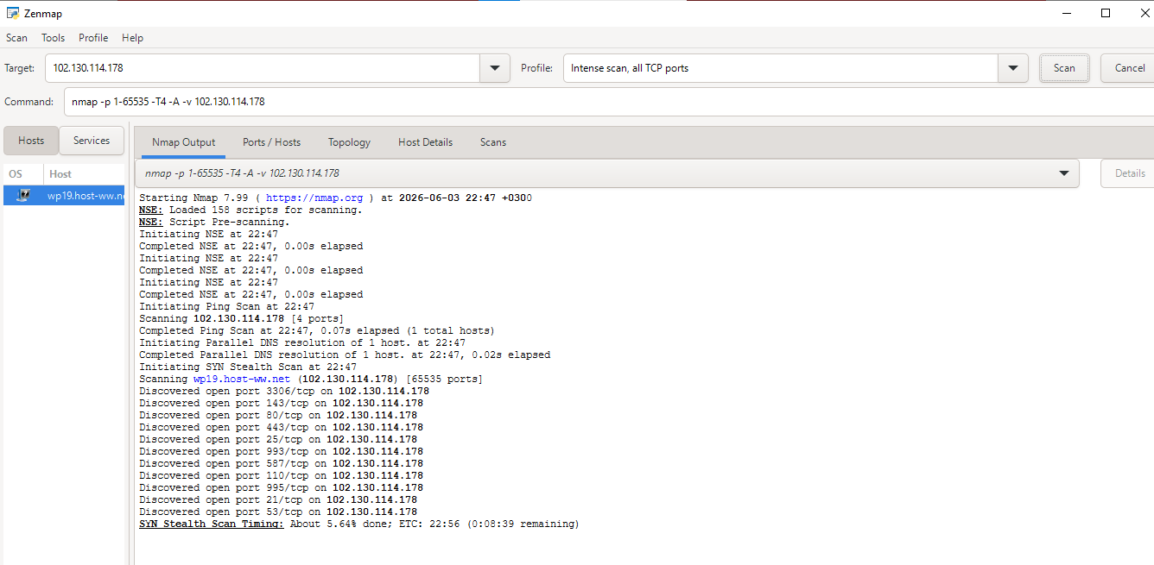

OS version scan:
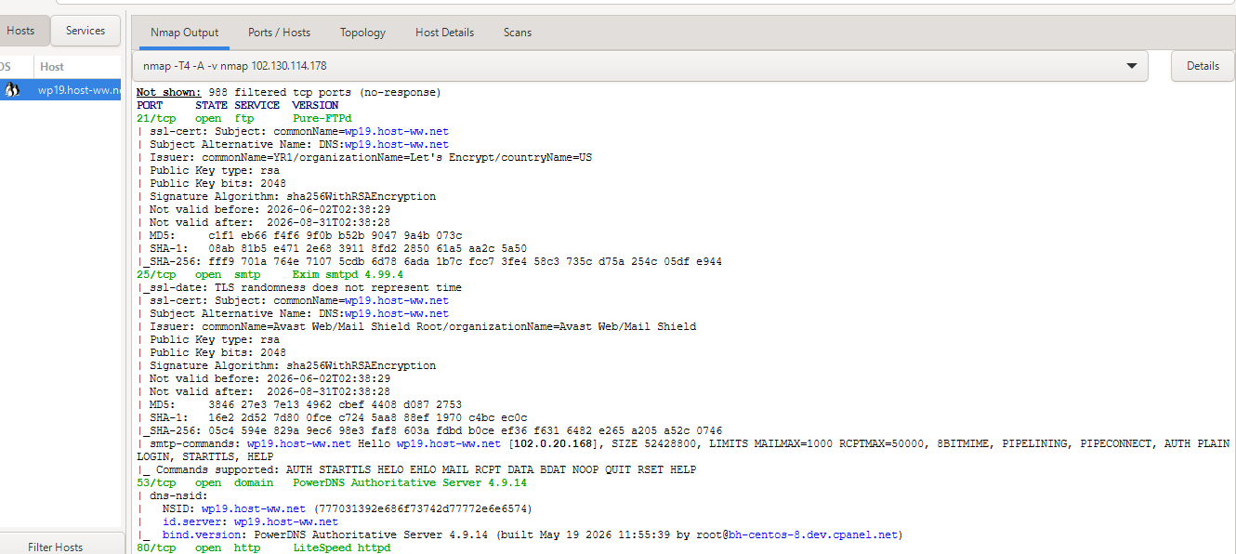
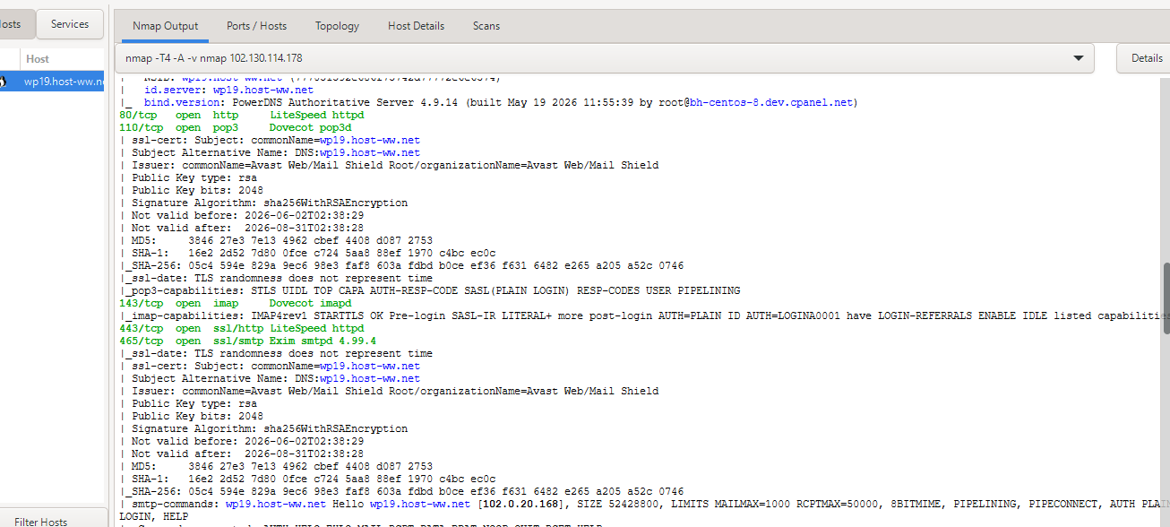
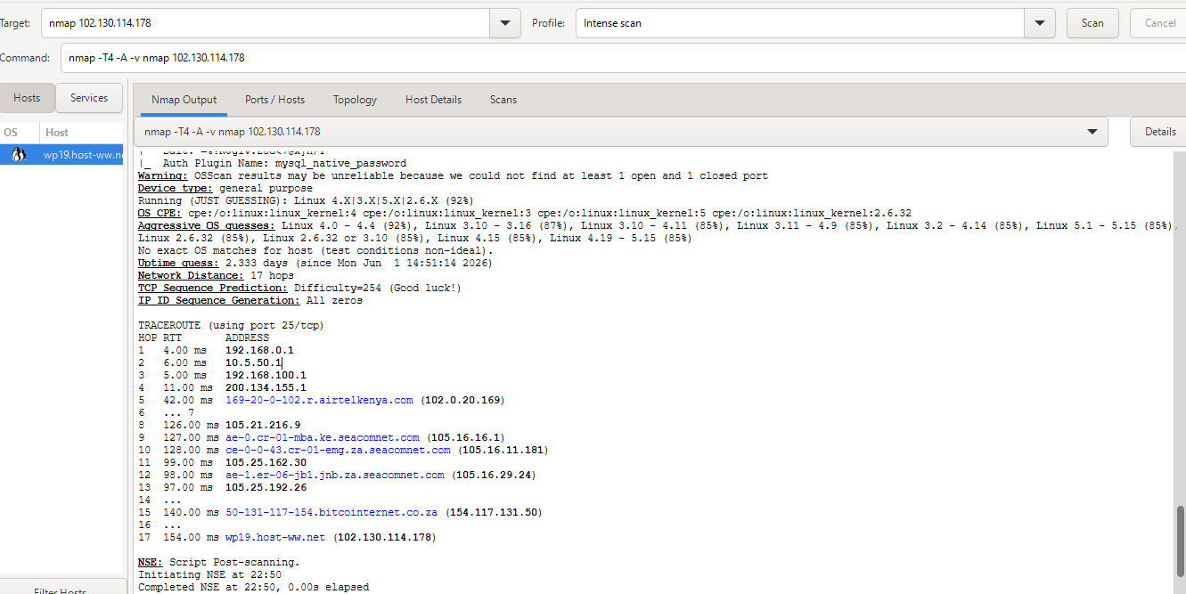
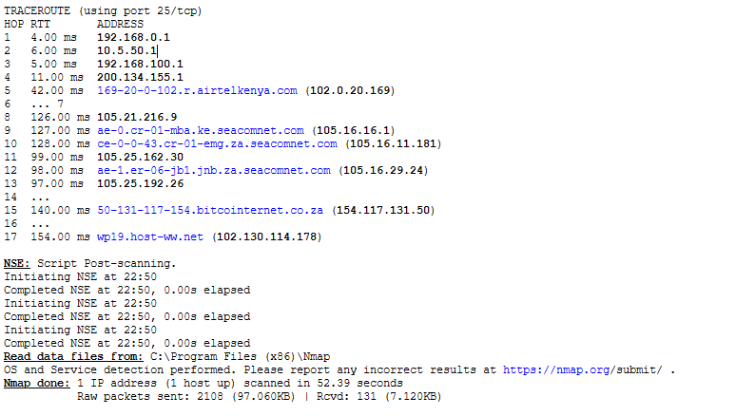Enumarate shared folders:
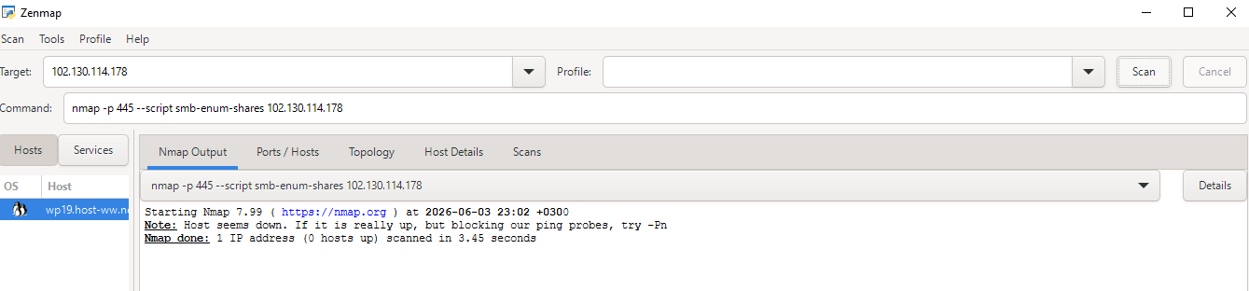
Student reflection:
What I have learnt while performing task 2,is how to identify live host of active work stations,open ports and operation system versions.Some of the challenges were that some ports were blocked so you could not get access to the information required.

Week 6: Vulnerability Assessment and Scanning

Practical Task 1

Basic Vulnerability Scan
Active Hosts & Open Ports Discovery
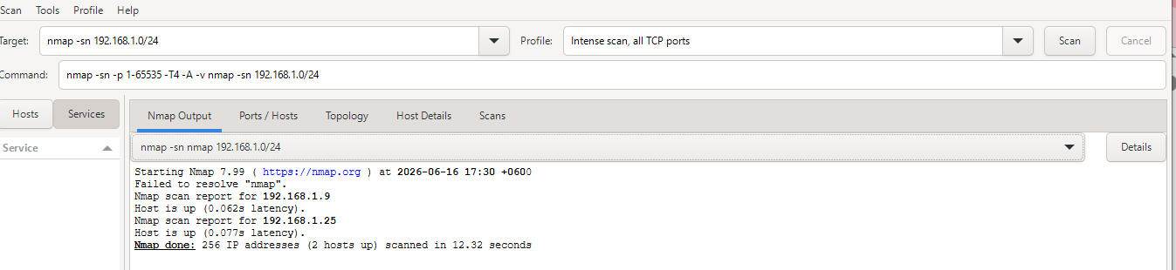
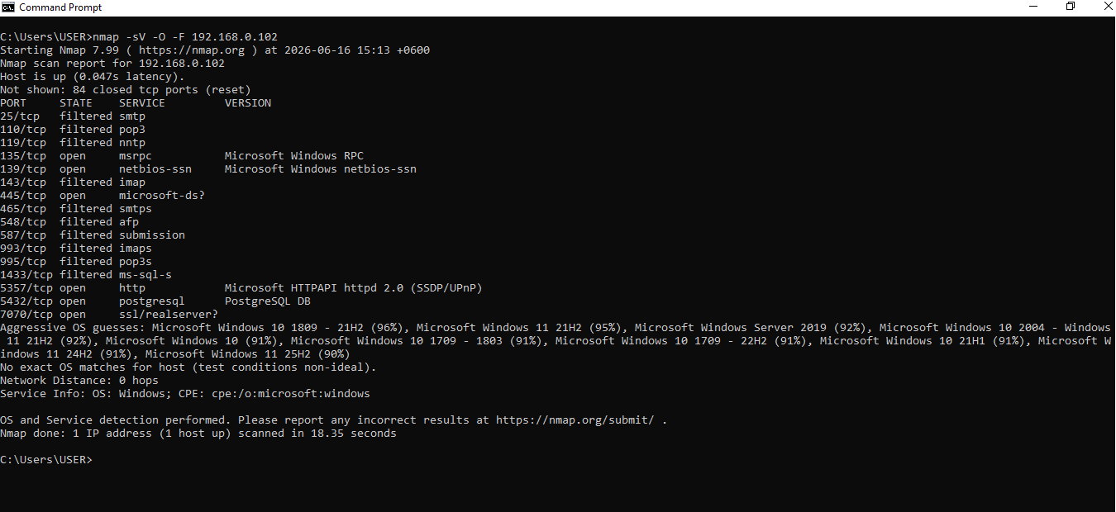

Practical Task 2

Vulnerability Research Assignment

Research five recent vulnerabilities.
CVE Number | Description | Severity (CVSS) | Potential Impact | Mitigation Strategy
CVE-2020-0601 | A spoofing vulnerability existing in the way Windows CryptoAPI (Crypt32.dll) validates Elliptic Curve Cryptography (ECC) certificates. | High (8.1) | Attackers can sign malicious executables or spoof secure HTTPS connections, making malware look like legitimate trusted software. | Install the January 2020 Microsoft Security updates for Windows 10, Windows Server 2016, and 2019.
CVE-2021-34527 | A remote code execution vulnerability found in the Windows Print Spooler service when it improperly handles unauthenticated file write operations. | Critical (8.8) | An unauthenticated attacker can gain full domain administrator privileges, modifying directories and installing unauthorized applications | Disable the Windows Print Spooler service on critical domain controllers and infrastructure servers where printing functionality is not required.
CVE-2014-0160 | A severe information disclosure flaw in the OpenSSL TLS Heartbeat extension that allows reading sensitive memory buffers of affected servers. | High (7.5) | Exposure of secret private cryptographic keys, user session cookies, unencrypted passwords, and confidential communications. | Upgrade OpenSSL to version 1.0.1g or newer
CVE-2026-11645 | Out-of-bounds memory access in Chrome’s V8 JavaScript engine. Exploited via crafted HTML pages | High (8.8) | Remote code execution inside browser sandbox; compromise of user sessions. | Update Chrome to latest version
CVE-2026-45586 | Windows Collaborative Translation Framework (CTFMON) privilege escalation | Critical | Local attackers gain system privileges, enabling full device takeover | enable least privilege and monitor for abnormal privilege escalation.

Practical Task 3: Organizational Vulnerability Assessment Plan
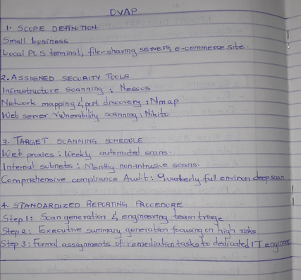

Advanced Practical Task

Vulnerability tracking spreadsheet
Vulnerability Name | Risk Level | Status | Assigned Personnel | Resolution Date
React2Shell RCE (CVE-2025-8671) | Critical | Resolved | Emma (Web DevSecOps) | 10/06/2026
Default Admin Credentials | Critical | Resolved | M. Wairimu (Dev) | 2026-06-13
Outdated Apache Web Server | High | Open | J. Doe (System Admin) | 17/06/2026
Open FTP Port | Medium | Open | A. Smith(Network Admin) | 21/06/2026

Challenge Task
Vulnerability Management Framework for an organization
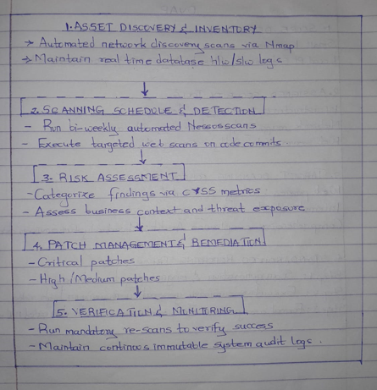

WEEK 7

Practical Task 1

OWASP Top 10 Research

1. Broken Access Control
Definition: Failure to enforce restrictions on authenticated users.
Example: A normal user accesses administrator pages by modifying a URL.
Impact: Unauthorized access to sensitive information and functions.
Prevention:
- Implement role-based access control.
- Verify permissions on every request.
- Deny access by default.

2. Cryptographic Failures
Definition: Weak or missing encryption exposing sensitive data.
Example: Passwords stored in plain text.
Impact: Data theft and privacy violations.
Prevention:
- Use strong encryption algorithms.
- Encrypt sensitive data at rest and in transit.
- Securely manage cryptographic keys.

3. Injection
Definition: Untrusted data is interpreted as commands or queries.
Example: SQL Injection:
' OR '1'='1
Impact: Database compromise and unauthorized access.
Prevention:
- Use parameterized queries.
- Validate input.
- Employ least-privilege database accounts.

4. Insecure Design
Definition: Security weaknesses resulting from poor application design.
Example: No account lockout after repeated login attempts.
Impact: Increased risk of attacks.
Prevention:
- Conduct threat modeling.
- Integrate security into system design.
- Perform security reviews.

5. Security Misconfiguration
Definition: Incorrectly configured security settings.
Example: Default administrator credentials remain unchanged.
Impact: Unauthorized system access.
Prevention:
- Harden systems before deployment.
- Remove default accounts.
- Regularly review configurations.

6. Vulnerable and Outdated Components
Definition: Use of software with known security flaws.
Example: Running outdated frameworks with published vulnerabilities.
Impact: System compromise.
Prevention:
- Maintain an asset inventory.
- Apply updates and patches promptly.
- Monitor security advisories.

7. Identification and Authentication Failures
Definition: Weak authentication processes.
Example: Weak passwords and lack of MFA.
Impact: Account takeover.
Prevention:
- Enforce strong passwords.
- Implement multi-factor authentication.
- Monitor login attempts.

8. Software and Data Integrity Failures
Definition: Untrusted software updates or data.
Example: Installing unsigned software updates.
Impact: Malware installation and system compromise.
Prevention:
- Verify digital signatures.
- Use trusted repositories.
- Secure CI/CD pipelines.

9. Security Logging and Monitoring Failures
Definition: Failure to detect or respond to security incidents.
Example: Failed login attempts are not logged.
Impact: Delayed detection of attacks.
Prevention:
- Enable centralized logging.
- Monitor security events.
- Establish incident response procedures.

10. Server-Side Request Forgery (SSRF)
Definition: Server fetches resources on behalf of attackers.
Example: Application retrieves internal URLs provided by users.
Impact: Internal network exposure.
Prevention:
- Validate URLs.
- Restrict outbound connections.
- Use allowlists.

Practical Task 2

Web Application Assessment

Practical Task 3

Security Improvement Proposal
Authentication Controls
- Implement Multi-Factor Authentication (MFA).
- Enforce password complexity requirements.
- Configure account lockout policies.
- Use secure password hashing (Encrypt).
Input Validation Measures
- Validate all user inputs.
- Use allowlists where possible.
- Sanitize user-supplied data.
- Employ parameterized SQL queries.
Logging Mechanisms
- Log authentication events.
- Record failed login attempts.
- Monitor administrative activities.
- Centralize logs using SIEM solutions.
Patch Management Strategy
- Maintain software inventory.
- Apply security patches monthly.
- Test updates before deployment.
- Monitor vendor security advisories.

Advanced Practical Task
Web Security Checklist :
Authentication
- Strong password policy
- MFA enabled
- Account lockout configured
- Password reset security verified
Authorization
- Role-based access control implemented
- Privilege escalation tested
- Direct object references protected
Input Validation
- Input validation performed
- SQL Injection protection implemented
- XSS protection enabled
- File uploads validated
Session Management
- Secure cookies enabled
- Session timeout configured
- Session IDs regenerated after login
Encryption
- HTTPS enforced
- Sensitive data encrypted
- Strong TLS versions enabled
Logging
- Authentication logs enabled
- Security events monitored
- Log retention policy established
Configuration Management
- Default credentials removed
- Unnecessary services disabled
- Security headers configured

Challenge Task
Secure Web Application Design Framework.
